**Ultra Range Detector**

**using**

**Arduino and SR-04F**

**Introduction**

Feedback Systems process signals and as such are signal processors. The processing part of a feedback system may be electrical or electronic, ranging from a very simple to a highly complex circuit.

Simple analogue feedback control circuits can be constructed using individual or discrete components, such as transistors, resistors and capacitors, etc, or by using microprocessor-based and integrated circuits (IC’s) to form more complex digital feedback systems.

Feedback Systems are very useful and widely used in amplifier circuits, oscillators, process control systems as well as other types of electronic systems. But for feedback to be an effective tool it must be controlled as an uncontrolled system will either oscillate or fail to function.

Arduino is an open-source electronics platform based on easy-to-use hardware and software. [Arduino boards](https://www.arduino.cc/en/Main/Products) are able to read inputs - light on a sensor, a finger on a button, or a Twitter message - and turn it into an output - activating a motor, turning on an LED, publishing something online. You can tell your board what to do by sending a set of instructions to the microcontroller on the board. To do so you use the [Arduino programming language](https://www.arduino.cc/en/Reference/HomePage) (based on [Wiring](http://wiring.org.co/)), and [the Arduino Software (IDE)](https://www.arduino.cc/en/Main/Software), based on [Processing](https://processing.org/).

Ultrasonic Range Detector is a module that is used to measure distance. The sensor can detect objects that pass through its range and it can also include the distance of the object by displaying the values on the LCD. This module can be ideal to objects that needs to be far from collision, home security as it can be used as an alarm when it detects someone and navigation, example is as a feature of vehicle that can help the driver to determine if he/she is near to a wall or another car when parking. This module can work both in daylight and night as it uses sound and not light.

**Project Description**

The module consists of two drums, one is the receiver which receives the reflected ultrasound and the other one is the emitter which emits the ultrasound from the object. The emitter drum emits the ultrasound when the module is triggered using the trigPin by sending 10 microseconds high pulse. The echoPin is high as soon as the ultrasound is emitted through the emitter module. Emitted ultrasound travels forward till it gets reflected by object and then travels backward. The receiver will detect the reflected ultrasound. When the reflected ultrasound is detected by the receiver, the echoPin is made low. Now the time take by the ultrasound to reach the object and again reach the source which is equal to the time which the echoPin was high. The time is stored in the microcontroller. As a result, the travel time of ultrasound between source to object is half the time to travel source-object-source.

**Schematic block diagram**

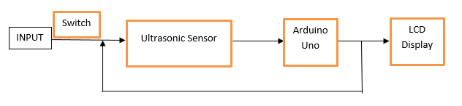

**Materials and Methodology**

Materials used:

* Arduino UNO
* Ultrasonic Sensor – HC-SR04
* Jumper wires
* Breadboard

In this project we have chosen the aid of a microcontroller, Arduino Uno Rev 3, as our electronic device for the feedback mechanism since Arduino is used for motor controls, sensor activation, and etc. We used HC-S04, which is an Ultrasonic sensor, as our main sensor because it is compatible with Arduino, and it’s more convenient to program and is user-friendly. The sensor works by first transmitting a sound wave. When the sound wave reaches an object, it will bounce back to the sensor’s receiver.

For the output, an LCD Display was used, soldered with solid wires and was pre-programmed to be suited for Arduino. The LCD Display shows the distance from the sensor to the object in front it. The jumper wires were used for the interconnection of the whole circuitry. The breadboard was used for easier distinction of the connections. Below is the Arduino code for the Ultrasonic Range detector:

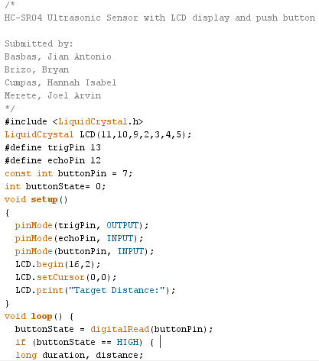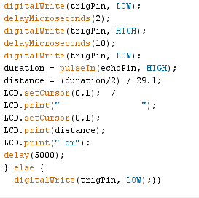

**Picture of the Prototype**

